Project Design Phase-II Technology Stack (Architecture & Stack)

|  |  |
| --- | --- |
| Date | 15 October 2022 |
| Team ID | PNT2022TMID27330 |
| Project Name | Project - Signs with Smart Connectivity for Better Road Safety |
| Maximum Marks | 4 Marks |

Technical Architecture:

The Deliverable shall include the architectural diagram as below and the information as per the table1 & table 2

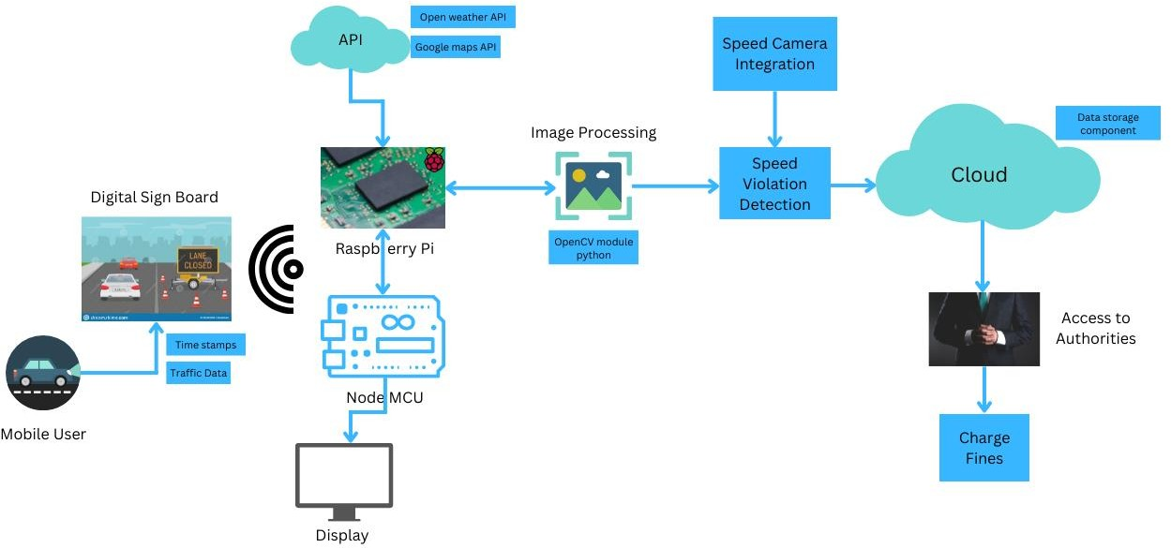

Table-1 : Components & Technologies:

|  |  |  |  |
| --- | --- | --- | --- |
| **S.No** | **Component** | **Description** | **Technology** |
| 1. | User Interface | Digital board UI | TTFL Display, Amoled |
| 2. | Application Logic-1 | Traffic Monitoring and Constructions indication ahead | Google Map API (Python) |
| 3. | Application Logic-2 | Speed Camera Integration for speed violation detection and data processing with Image  Processing Technique | OpenCV Module (Python) |
| 4. | Application Logic-3 | Speed Limitations based on weather data | Weather API (Python) |
| 5. | External API-1 | Traffic Monitoring and Constructions ahead | Google Map API (Python) |
| 6. | External API-2 | Speed Limitations based on weather data | Weather API (Python) |
| 7. | Machine Learning Model | Purpose of Machine Learning Model | Object Recognition Model, etc. |
| 8. | Infrastructure (Server / Cloud) | Application Deployment on Local System / Cloud Local Server Configuration: Data Storage  Cloud Server Configuration: Data Process | Local Data, IBM cloud (or) Google Drive |

Table-2: Application Characteristics:

|  |  |  |  |
| --- | --- | --- | --- |
| **S. No** | **Characteristics** | **Description** | **Technology** |
| 1. | Open-Source Frameworks | Visual studio Code, Node-Red | Python |
| 2. | Scalable Architecture | Implementation and Maintenance cost will be less, so  that the product is highly scalable. | IoT Watson Platform |
| 3. | Availability | It will available for working every 24/7. | IBM Cloud, Google Drive |
| 4. | Performance | Acceptable performance with dynamic updation of  data regarding weather, traffic, etc.. | IBM Cloud, Google Drive |

References: <https://nodered.org/> <https://code.visualstudio.com/>

<https://www.ibm.com/cloud/architecture> [https://drive.google.com](https://drive.google.com/)